

**NAME**  HASNAIN RASOOL   
 USAMA HAIDER

**REG NO** 19-NTU-CS-1100

19-NTU-CS-1129

**ASSIGNMENT TITLE**  VISCOSE FIBER

**SUBMIT DATE** 17-05-2022

**SUBMIT TO** Sir Hafiz Shahbaz Sb.

**National Textile University, Manawala, Faisalabad**

# Contents

Contents 2

Textile Fibers and its Classification 3

Rayon 3

Viscose Rayon 5

Manufacturing of Viscose Rayon 6

Commercial Name: 8

Properties of Viscose Rayon 8

Comparison 9

End User Applications 10

# Textile Fibers and its Classification

# Rayon

* It is regenerated cellulose fiber.
* Start from Germany
* Rayon is oldest fiber.
* It is man-made based on cellulose.
* Cellulose is most usable natural polymers worldwide
* Two Main Raw Material:
  + Wood Pulp
  + Cotton linters

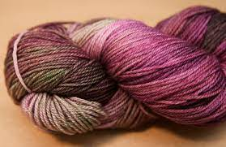

Figure 1:Rayon Fiber

* Firstly, Named as Artificial Silk
* Because it is shine like silk
* It is also called chemical cellulose & dissolving pulp that is used to made different types of Rayon.
* Different process led to the production of rayon fibers, viscose rayon, cuprammonium rayon and saponified cellulose acetate.
* There are Four types of Rayon.
  + Viscose Rayon
  + Acetate Rayon
  + Nitro Cellulose
  + Cuprammonium Rayon

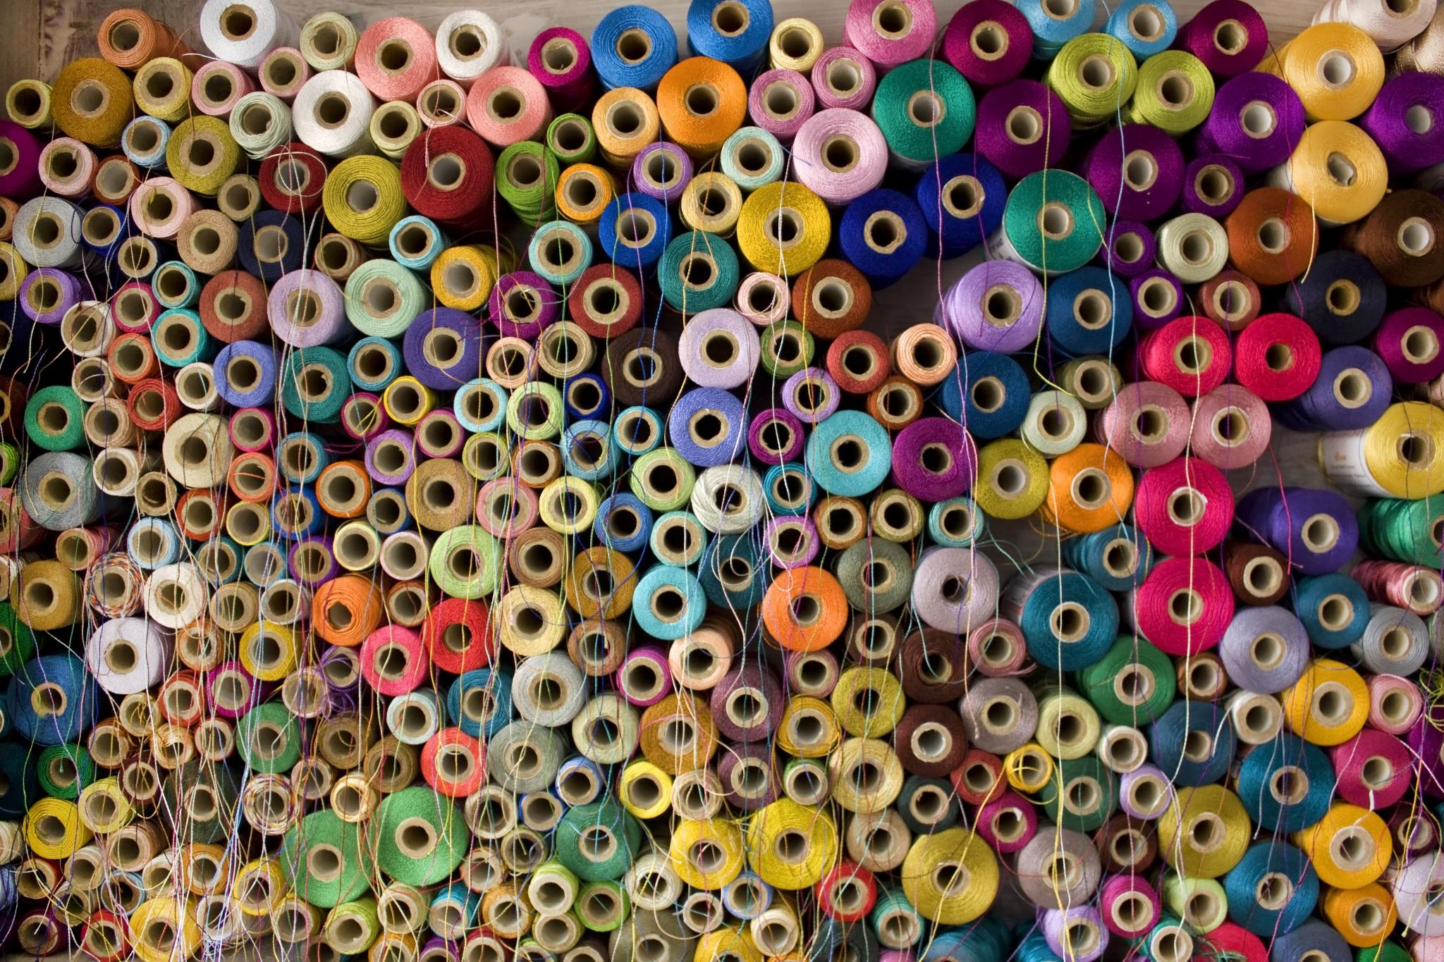

Figure 2:Rayon Fiber

# Viscose Rayon

* The process used to make viscose can either be a continuous or batch process.
* Batch processing is flexible in producing a wide variety of rayons
* The continuous process is the main method for producing Rayon

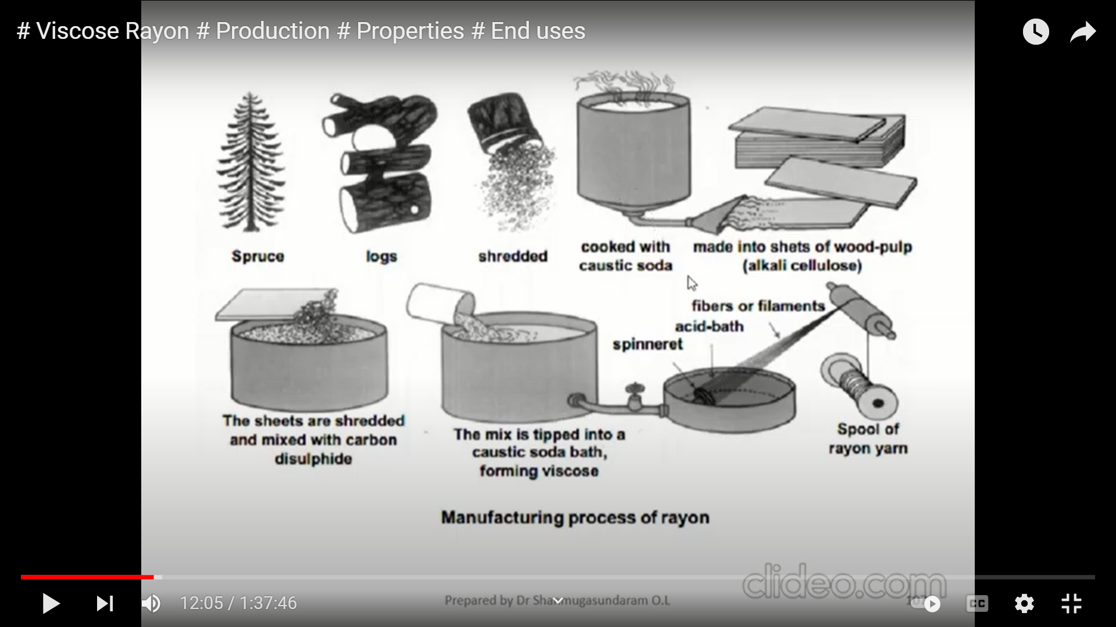

# Manufacturing of Viscose Rayon

* Steeping

Steeping is the very first step in the manufacturing of viscose. In this process, the pulp is treated for mercerization in presence of NaOH at the mercerizing strength. The pulp sheets are then steeped (immersed) in 18% NaOH. Alkali cellulose is generated as product during the reaction.

* Shredding

During shredding, the alkali sheets are then converted in light fluffy mass with the help of a machine which consists of a pair of revolving blades rotates at a high speed in the opposite direction.

* Ageing

The crumbs obtained at the end of the shredding procedure are transferred to a steel container where they are stored under specific temperature for 3 to 72 hours which may vary according to the catalyst and the alkali. The presence of air in the alkali reduces the chain length which in turn decrease the viscosity as it is essential to prepare the desirable spinning solution. As soon as the correct viscosity is obtained these pieces are then transferred into a drum where it is kept in inert atmosphere and kept at low temperature.

* Xanthation

During the process of xanthation the aged alkali cellulose crumbs are placed in vats and are allowed to react with carbon disulphide under controlled temperature 20–30-degree Celsius which forms cellulose xanthate.

* Filtration

The viscose is filtered to remove undissolved materials that might disrupt the spinning process or cause defect in the rayon filament.

* Blending

In blending process, we mix viscose with other fibers to make new fibers. Sometimes we perform to make consistent and homogenous mixture of fivers.

* Ripening

In this process, the viscose is allowed to ripen for a stipulated period. During ripening, two major processes take place firstly, the xanthate groups are redistributed and then lost. The viscosity of the solution first decreases and then rises to its original value.

* Wet spinning

In this process, the ripened viscose solution passes through a centrifugal pump due to pressure exerted on the solution by the compressed air. Then viscose solution is forced through a spinneret which has many fine holes with diameters ranging from 0.05- 0.1mm, as soon as several filaments emerge from the spinneret, they are taken together to surface of the spinning bath and then it is guided to two roller from where they are wound on to a spindle.

* Drawing / washing / Cutting

In drawing and washing, we perform this process to clean and cut the fibers.

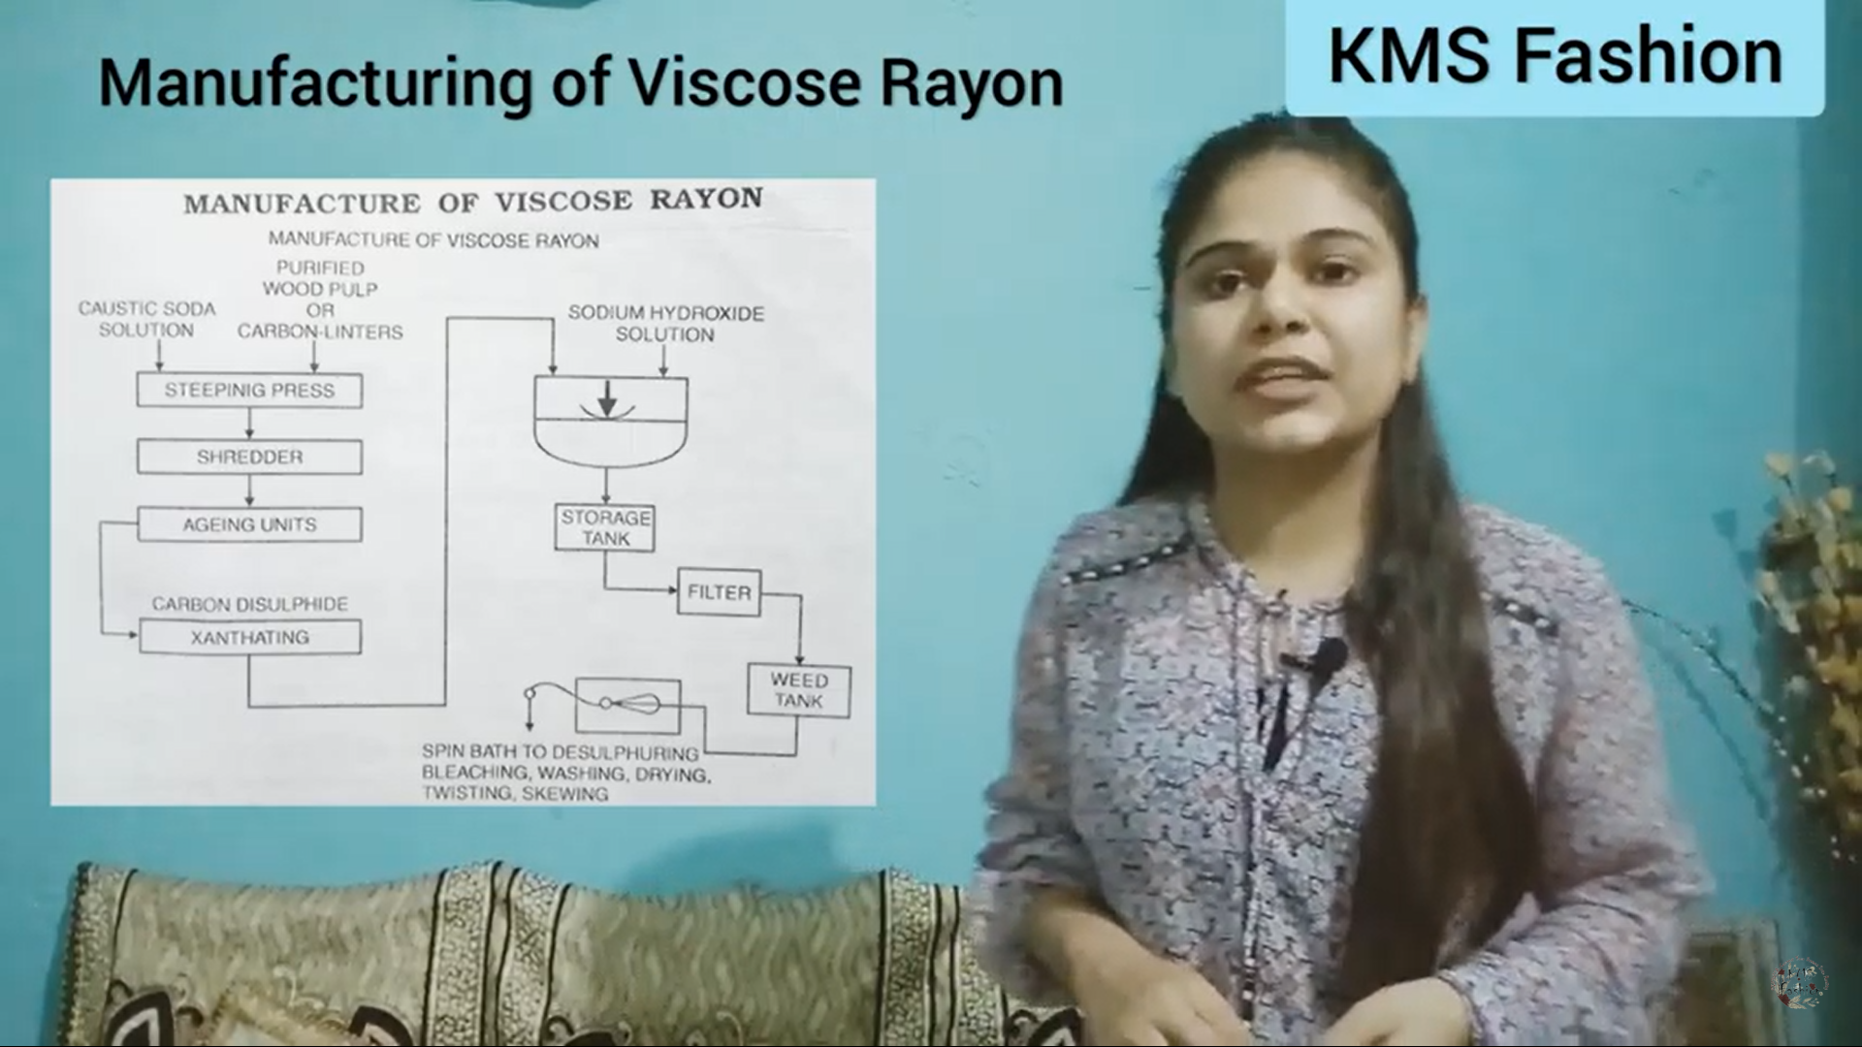

# Commercial Name:

* The commercially name of viscose Rayon are.
  + Zantral
  + Avril
  + Fibro HSO
  + Grasim

# Properties of Viscose Rayon

* Synthetic not environmentally friendly
* High strength
* Due to Cellulose base fiber, it is affected by acid, or less effect by weak alkali.
* Smooth
* Shine
* Filament Long
* No sunlight effects
* Weak friction
* Biodegradable
* Softness
* Viscose is the most absorbent of all cellulosic fibers even more so than cotton or linen
* It gives appearance and feels as soft and silky and very comfortable
* Easily dyed in various colors
* When heating the viscose fiber, it does not shrink
* Viscose can be blend with other fibers.

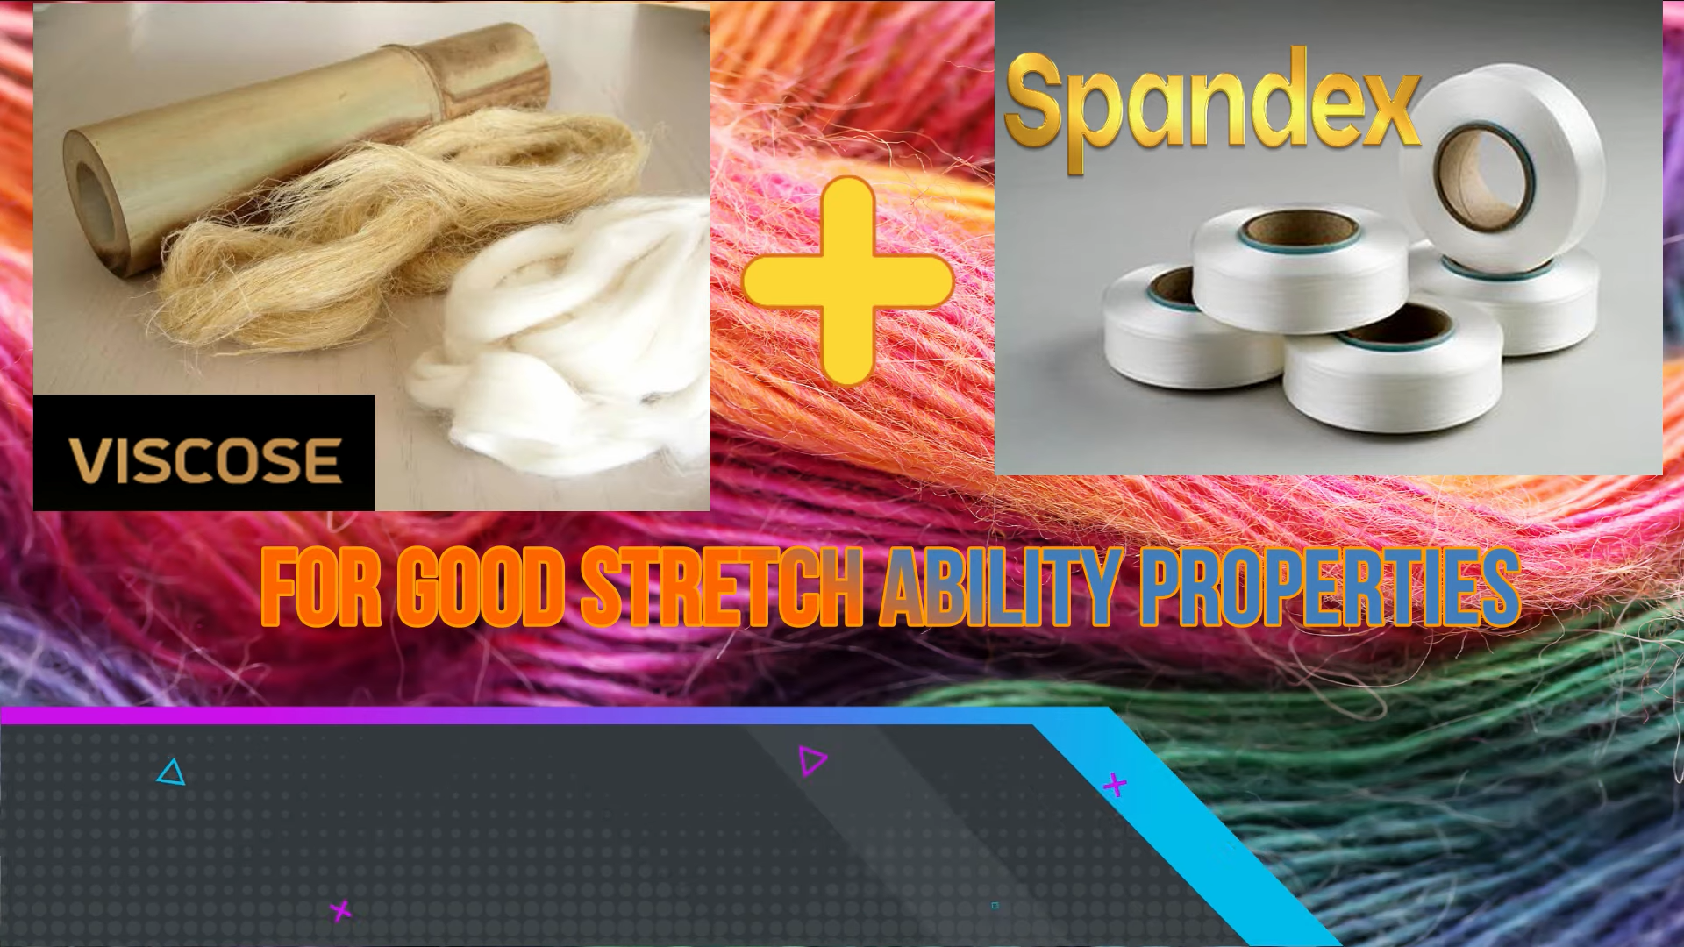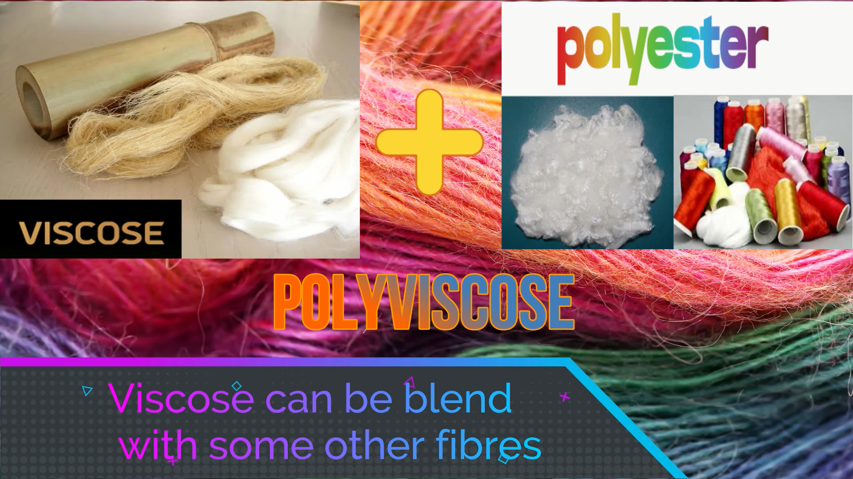

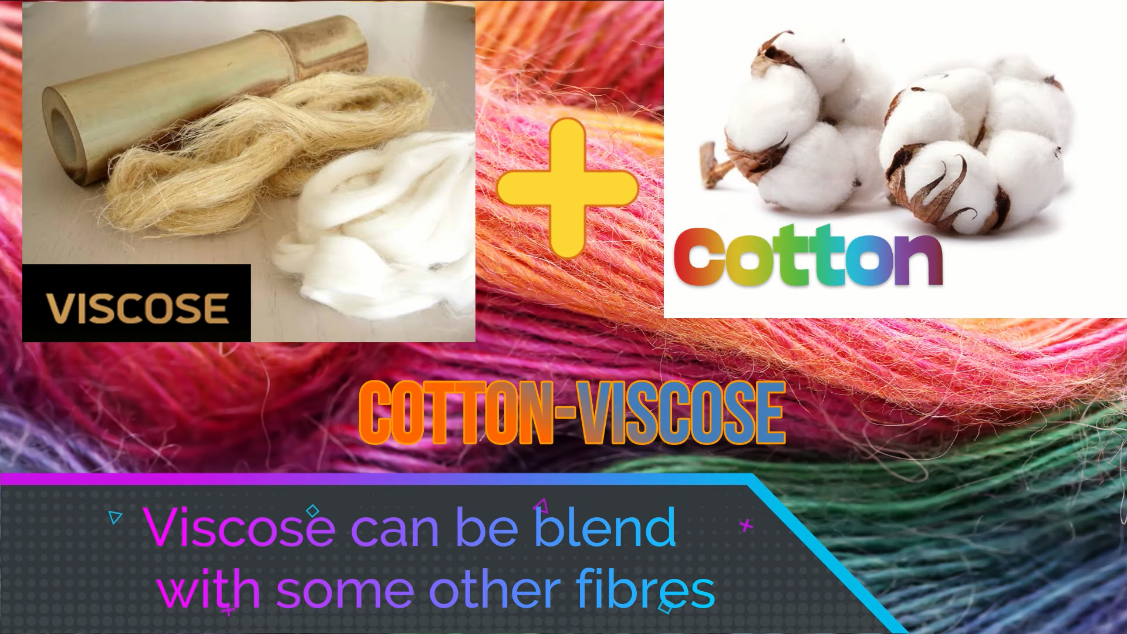

# Comparison

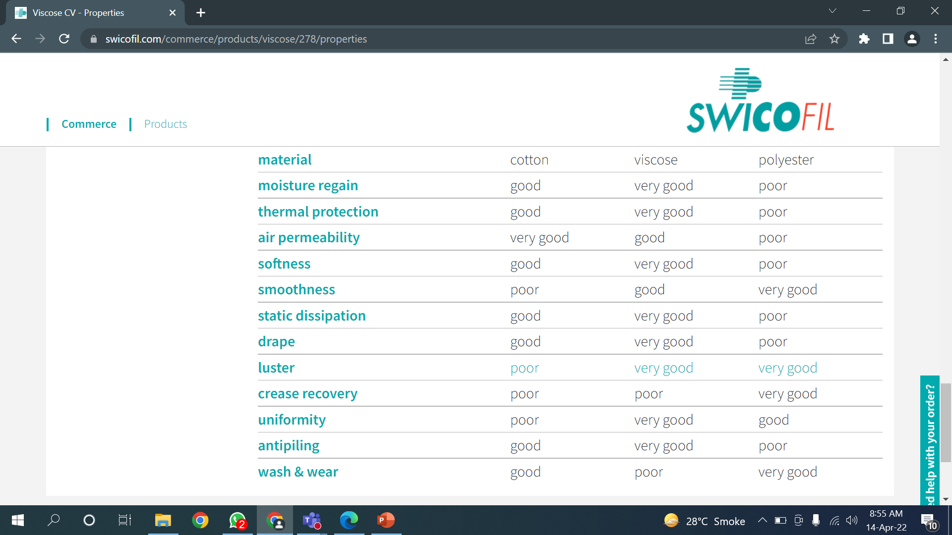

# End User Applications

* The softness and luster in fiber make it a preferred choice for ladies' garments and men's wear.
* Mostly used in:
  + Children Clothes
  + Suits
  + Sari
  + Dresses

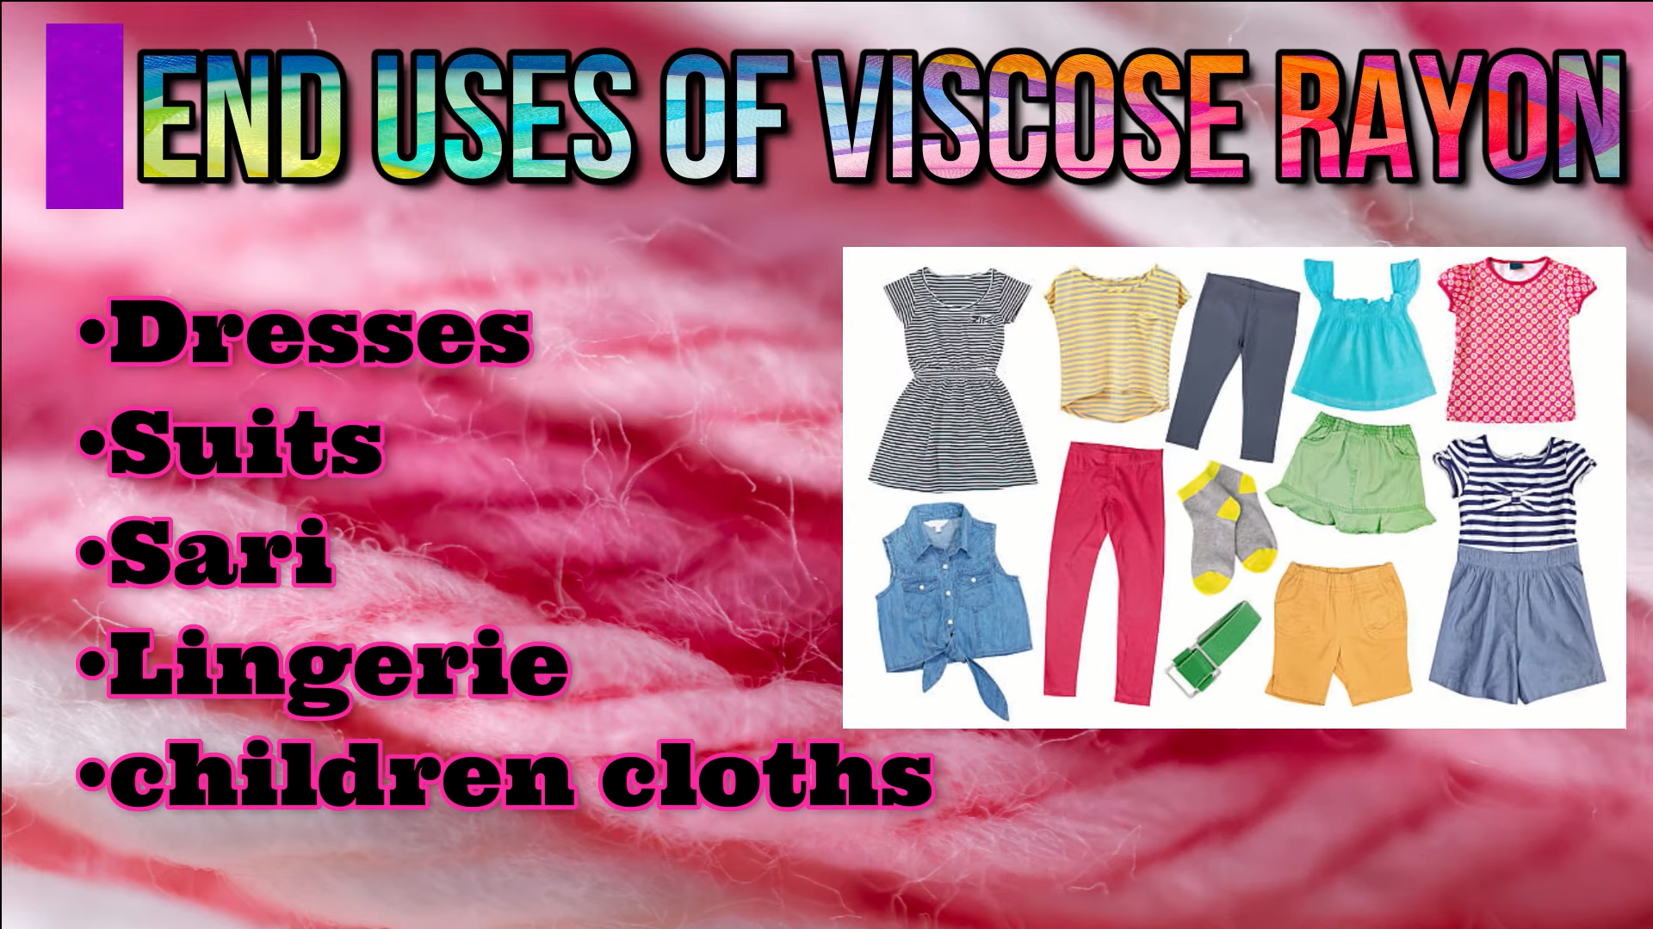

* It is used in making umbrella clothes and protective clothes.

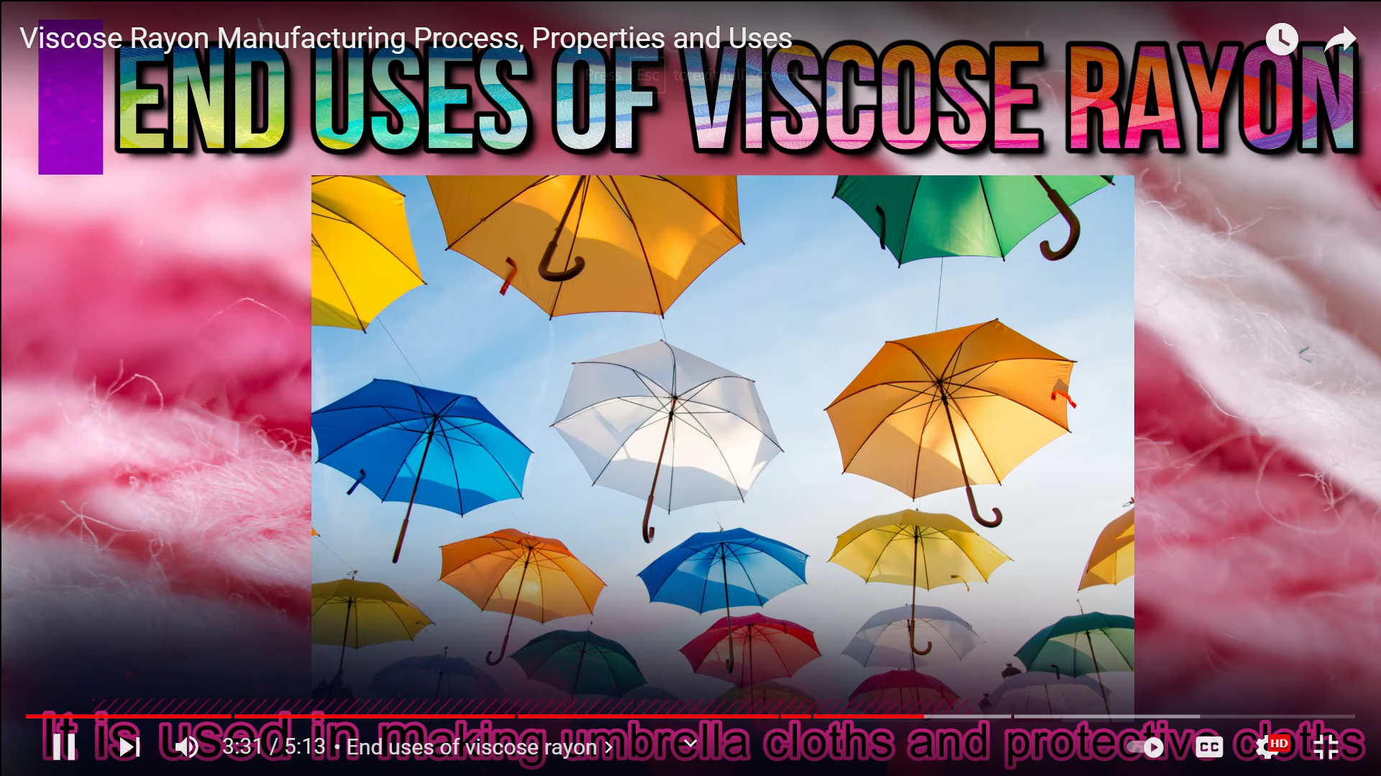

* It is used as sewing threads

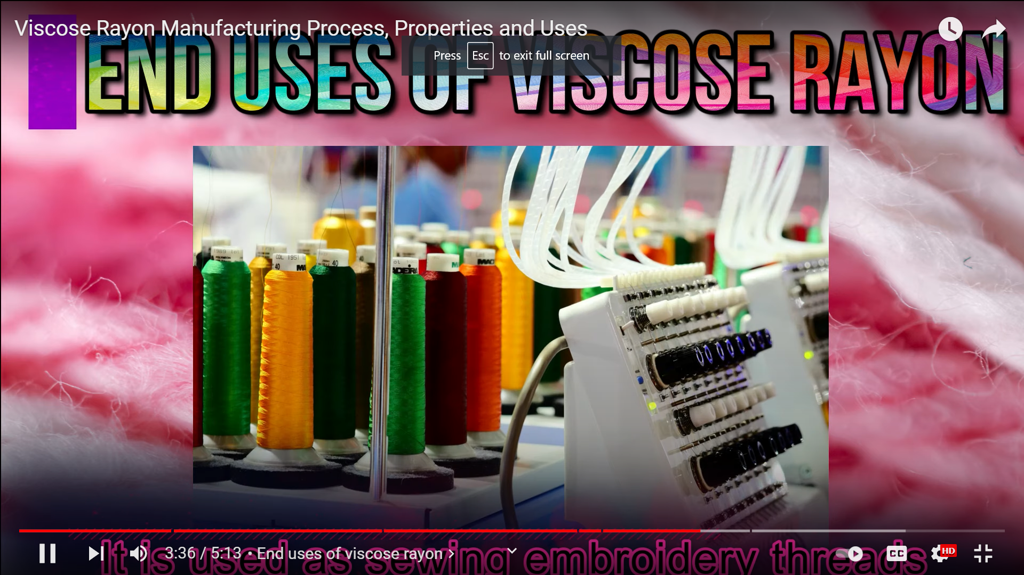

* Curtains
* Sport wear
* Cushions

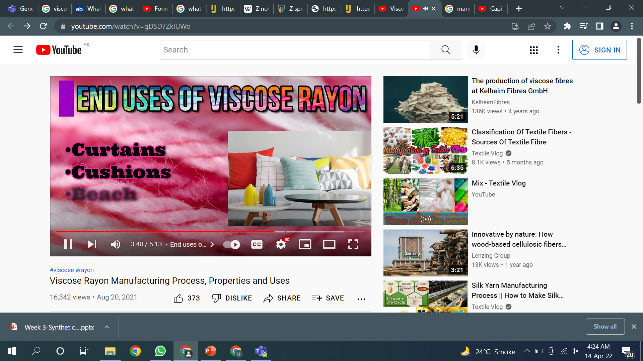

* Viscose is also used in non-woven such as baby wipes.